**15.2.1**

Hi

Hi Khae, You’re actor gym.

I want to be heathy.

Can I use it?

Yes, you can

Great

**Does your family live in New York?**

No, **My family lives in ThaiLand.**

Where does your family live?

**My family lives in India.**

**How big is your family?**

Big, **I have one sister who is twenty years old.**

**Do you have any brothers?**

A lots

How many?

Three

One is 18 years old, One is 26 years old and One is 29 years old. Two of My brothers work for my father at his company. He live in home

That’s a big family

Do they visit to New York?

No, But my 29 year old want to visit

Is he married?

Yes, he is. His wife , son, and daughter can not visit. The kid is busy with school. They are students.

Where are Khae ans Aanya?

--> At the gym

what are Khae an Aanya talking about?

--> Family

Where does Khae's family live?

--> Thailand

Aanya has a lot of brothers

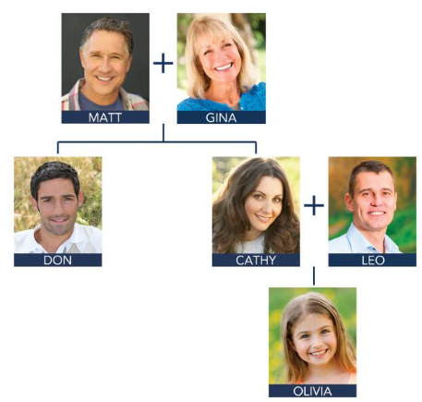

Matt and Gina are married. Matt is Gina's husband. Gina is Matt's wife.

Cathy and Lao are married. Leo is Cathy's husband.

Matt is Don's father.

Matt ans Gina have two children: Don and Catthy. Don is Cathy's brother.

Cathy is Olivia's mother.

Don is Gina's son.

Cathy is Matt's daughter.

Cathy is Don's sister.

My name is Ted. I live in California. I am married. My wife’s name is Ann. We have a big family! We have two sons and two daughters. One son’s name is Josh. He’s five years old. One son’s name is Brad. He’s nine years old. My daughters’ names are Lisa and Grace. Lisa is seven years old, and Grace is one year old!

Ted is Ann’s => husband

Ted is Josh’s => father

Ann is Lisa’s => mother

Brad is Grace’s => brother

Lisa is Josh’s => sister

Grace is Ann’s => daughter

Brad is Ann’s => son

**Conversation**

Does your family live in New York , Elio?

No, My family lives in Italy

**How big is your family?**

It’s big. I have three sisters

Woa, How old are they?

One is 17 years old, One is 15 years old and One is 13 years old.

Do they live at home?

Yes , They do. They live in Rome with my parents.

Do you have any brothers?

I have one brother He’s 25 years old

Does your brother live at home?

No , He’s married. He lives with his wife in an apartment.

Do they have any chidren?

Yes. They do, They have two sons.

Lydia and Diego are married. Lydia is Diego’s wife.

Lydia and Diego are married. Diego is Lydia’s husband.

Lydia and Diego are married. They have two children.

Angela is Diego’s daughter.

**15.2.2**

Tell me more about your brother. **What is his job?**

**He's an architect.**

**And you're an engineer.** You have a smart family

Thank you. Do you have any brothers and sister?

**I have one brother. He's a cook**. He work in a noodles shop. My parents's noodles shop. He **was an Artist but it doesn't pay well**

**My parents want my brother, Aadi to be a doctor**

My parents want my brother to be a doctor

He like my job and want to be engineer, not a doctor. **I want him to be an Artist.** **He’s a good painter.** He paints a beautiful picture

That's cool.. What was that?

I don't know

Khea and Aanya are talking about their brothers

Aanya and her brother are smart

Where does Khae's brother work?

--> Aanya's brother

Aanya wants her brother to paint

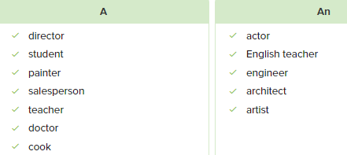

**Conversation**

Do you have any brothers or sister, Ella?

Yes , I have one brother and one sister

Tell me about your brother. What’s his job?

He’s a math teacer.

On. That’s cool

He’s an Artist before

Does he want to be an artist now?

No, It doesn’t paint well. But he’s good teacher. And he likes it.

What about your sister. What’s her job?

She’s an English teacher.

Wow are your parent teacher , too?

My father is a teacher But my mother is a salesperson store.

What about you? Do you want to be a teacher?

No, I don’t I want to be a cook

**Exercise**

What’s your job?

* **I’m an** engineer

I like this restaurant. **The waitress** is nice

What does your brother do?

* He is **a** taxi driver

Jeff, do you wnat to be **an architect**

Is she a math teacher?

* No. She is **an English teacher**

I **am a** salesperson in a clothing store

Does she have a job?

* No. She is **a student**

**Doctors** work hard. They have difficult jobs

Are your sisters **artists**?

* No, they aren’t. They don’t have jobs

**15.2.3**

He doesn't every them in here

Oh. You can do it. Breathe! Lift!

**What’s wrong?**

I could _ here. **The bar is heavy**

**What can we do ?**

**We need to help him**

Yes. C all for help

**Can you call for help?**

**I can go get someone**

No, it’s OK

**Can you help him?**

Yes.

Can you help me? You’re woman

Yes. I am

**What are you doing?**

**I’m helping you**. I like going to the gym

Thank you. I have to go now. I have an important meeting

I want to try it

Do you want to try it?

Yes. I do

You can do it. Verry good. You’re strong

Thank you

**Benny** needs help

Aanya and Khae **don’t call** for help

Benny **doesn’t have** an important meeting

**Benny** is not strong

What are you doing?

* I’m calling for help

Can you help me?

* Yes. I can

What can we do?

* We can go get help for them

What’s wrong?

* I’m sick

Are you hungry?

* Yes, I am. Can I have some pizza

We need coffee. Where is the store?

* It’s on 5th Avenue and 23rd Street

What do you need?

* I need a new computer

Where do you live?

* I live in an apartment downtown

What’s your job?

* I’m a salesperson

Do you have any brothers?

* No. I don’t

**Conversation**

Hi Benny. You are buying a lot of food . Are you hungry?

Hi LiLi. Yes I am. I need food for dinner

Oh. Are you thirsty too?

Yes. I am. I need drinks. Where are they?

The drinks are next to the breads

Greate. Thanks. I need 5 colas

Is Shen here too?

No, he isn’t

Is he at work?

No. He is at home. He doen’t have a job

Hey. What’s wrong?

This bag is heavy

Oh. Can I help you?

No. It’s ok. I can do it

**Exercise**

Can you help me?

* Yes, I can

What are you doing?

* I’m cooking dinner

What’s wrong?

* This soup is disgusting

What is your job?

* I’m an engineer

Can you call for help?

* Yes, I can

Do you have a big family?

* Yes, I do. I have six brothers and sisters

My phone isn’t working! Can you fix it?

* No, I can’t. I don’t understand phones. Sorry

Excuse me. Where is Min’s Chinese Restaurant?

* Turn right on Beddow Street. The restaurant is on your left

**Lesson Exercises**

I have two brothers and a sister

I have six brothers and two sisters

Do you have any children?

My sister’s a teacher

Can you fix it?

My mother is married to my father

My sister, Jill, say she’s going to be a famous singer

Mrs. Patel is Mr.Patel’s wife. They’re married

Adam is my brother but he doesn’t live at home

I have six brothers and two sisters. It’s a very big family

How many children do your parents have?

* One. I have no brothers or sisters

How old is your brother?

* Three years old

Where does your sister live?

* She lives at home with my parents

Where does your brother live?

* He lives alone in Australia

My brother, Alex Lee, designs buildings. He’s an architect.

My sister Serena helps sick people. She’s a doctor.

Is your mother an artist?

My brothers are cooks at the restaurant next door.

My sister was a painter, but now she's an architect.

Can you help me?

* No, I can’t. But I can go get someone

What’s wrong?

* This chair is heavy. I can’t lift it

Do you want to try it?

* No, I don’t. Not today

What is she doing??

* She’s helping him make chiken soup

What can I do for you?

* Can you help me fix the sink?

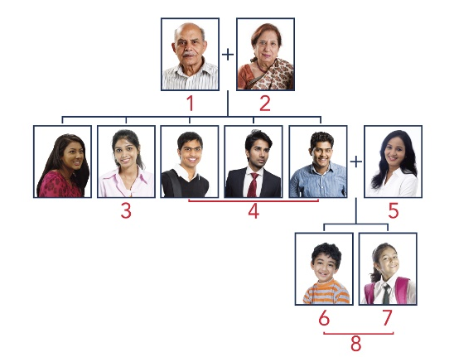Workbook

**1/8**

1 He is Aanya’s father.

2 She is Aanya’s mother.

3 She is Aanya’s sister.

4 They are Aanya’s brothers.

5 She is his wife.

6 He is their son.

7 She is their daughter.

8 They are their children.

[10:14:04 PM] Phan Thanh Dũng: 2/8

[10:14:05 PM] Phan Thanh Dũng: Aanya: Hi, Toshi. What are you doing?

Toshi: I’m looking at my new pictures.

Aanya: Is this your (1) **family**?

Toshi: Yes. These are my parents. My (2) **father** is 65 years old. He’s an engineer. My mother is (3) **63 years old**. She’s a teacher.

Aanya: Do they (4) **live** in New York?

Toshi: No, they are in Japan.

Aanya: Who are these people?

Toshi: This is my (5) **brother** Taka.

Aanya: How old is he?

Toshi: He is (6) **25 years old**. This is his (7) **wife**, Yuna.

Aanya: Do they have (8) **children**?

Toshi: No, they don’t. This is my (9) **sister** Rina. She’s (10) **19 years old**. She’s a student.

Aanya: Is she (11) **married**?

Toshi: No, she’s (12) **single**. She lives (13) **at home** with my parents.

Aanya: And this is you, your wife, and (14) **daughter**! You look very happy.

3/8

1 Shen’s father is a is painter.

2 Benny’s mother is an English teacher.

3 Aanya’s brother is an architect.

4 Benny is a salesperson.

5 Khae’s brother is a cook.

6 He was an artist.

4/8

Jason is **an** engineer. He works in **an** office in San Francisco. He has **a** brother and two sisters. Jason’s mother is **a** doctor, and his father is **an** architect. Jason’s brother is **a** teacher. He teaches math. Jason’s sister also teaches. She is **an** English teacher. His other sister is **a** cook in **a** restaurant. Jason has **a** wife and **a** daughter. His wife’s name is Dana. She is **an** artist. She paints pictures. Jason’s daughter Claire is **a** student.

5/8

Where are you?

* I'm at my parents' house.

What's wrong?

* This box is heavy. I need help

What can I help you with?

* Can you help me clean these dishes?

Do your parents live in Canada?

* No, they are in China.

Can you help me?

* Sure. What do you need?

Are you okay?

* No, I'm not. I'm sick.

6/8

Li Li: Hi, Benny.

Benny: Hi, Li Li. What are you doing here?

Li Li: I'm here to see Shen. Is he home or at work?

Benny: He's home. He doesn't have a job.

Li Li: Do you have a job?

Benny: Yes. I'm a salesperson.

Li Li: Are you okay?

Benny: I need help!

Li Li: What's wrong?

Benny: This box is heavy. Can you get Shen to help me?

Li Li: I can help you.

Benny: You can't help. You are a woman.

Li Li: Benny, I'm a woman, but I'm strong!

7/8

1 Who are Haruto and Junko? What are their jobs? How old are they?

* They are Toshi’s parents. Haruto is an engineer. Junko is a teacher. Haruto is 65 years old. Junko is 63 years old.

2 Who is Toshi’s wife? What is her job? Who is Toshi’s daughter?

* Toshi’s wife is Mei. She is a doctor. Toshi’s daughter is Saki.

3 Does Toshi have brothers or sisters? What are their names? What do they do?

* Toshi has a brother and a sister. Their names are Taka and Rina. Taka is an architect. Rina is a student.

4 Is Taka married?

* Yes, he is married. His wife’s name is Yuna.

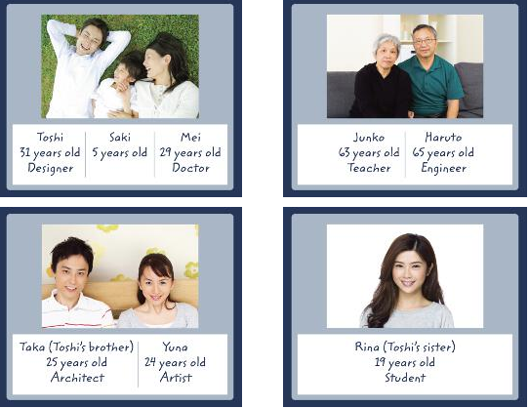

8/8

My name is Key. My parents are Joanna and Ricardo. My mother is 56 years old. She is an architect. She works in a big office in Milan. My father is 58 years old. He’s a doctor. I have a big family. I have two brothers and one sister. My brother, Ernesto is married. His wife’s name is Juliana. Ernesto is 32 years old. He is an engineer. Juliana is 31 years old. She is a teacher. They have a daughter, Carolina. She’s one year old. My brother Giorgio is 27 years old. He’s a taxi driver. He’s single. My sister, Mariana is 25 years old. She’s married. Her husband’s name is Federico. He is 29 years old. Mariana is a cook. Federico is an artist. I’m 22 years old. I’m single. I’m a student, and I live at home with my parents. My family lives in Milan, Italy.